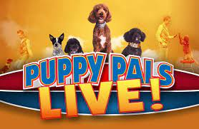

- Puppy Pals is a family fun action-packed show where adopted and rescued dogs perform spectacular stunts and breathtaking feats.
- The show features 4 dogs.
- Puppy Pals Show can be done inside or outside and can adapt to any size area.
- The length of the show is typically 45 – 60 minutes with intermission for dogs to rest.
- The show comes with everything needed including props and PA system.
- The audience gets to take pictures with puppies and interact with them after the show.
- Puppy Pals were featured on America’s Got Talent.


727-789-4594 / williamclare.com

